

Votiro Cloud for Web Downloads

User Guide

# February 2021

**Copyright Notice**

The material herein is proprietary to Votiro CyberSec Ltd. This document is for informative purposes. Any unauthorized reproduction, use or disclosure of any part of this document is strictly prohibited.

Votiro CyberSec’s name and logos are trademarks of Votiro CyberSec Ltd., its subsidiaries or affiliates. All other company or product names are the trademarks of their respective holders.

[www.votiro.com](http://www.votiro.com/)

# Contents

##### Introduction 4

* 1. Architecture and Data Flow 5

##### Installing Votiro Cloud for Web Downloads 7

* 1. System Requirements 7
     1. Hardware Requirements 7
     2. Software Requirements 7
     3. Network Requirements 8
     4. Internet Connectivity 8
  2. Running the Installation Wizard 9
  3. Post-Installation Steps 14
     1. Verifying that the File Connector Service is Running and Active 14
     2. Verifying that File Processing for Positive Selection is Active 14
     3. File Changes During Positive Selection Processing 14
  4. Uninstalling Votiro Cloud for Web Downloads 15

##### Configuring Votiro Cloud for Web Downloads 16

* 1. Configuring File Connector 16
  2. Policy Configuration 16
  3. Configuring Additional Channels 18
  4. General Configuration Parameters 22
  5. Votiro Cloud for Web Applications Configuration Parameters 23
  6. Logs Configuration Parameters 24

# Introduction

Votiro Cloud for Web Downloads safely automates the file sharing process, allowing you to communicate, access, collaborate, and perform file transfers safely and without disrupting your workflow.

Votiro Cloud for Web Downloads manages file transfers in a separated network environment, on local or remote servers. Using Positive Selection™ techniques all known and unknown threats from external networks are eliminated before they can enter your internal network. Positive Selection™ ensures only known elements from files across multiple devices and data sources are transferred to your internal network.

Votiro Cloud for Web Downloads can be installed on any file server such as FTP, SMB, FTPS, or local folders on the server.Votiro Cloud for Web Downloads draws the files from local or remote folders, processes them for Positive Selection™ and sends them to an internal designated local or remote folder - 100% safe to open and edit.

Votiro Cloud is an enterprise product, supporting hundreds of thousands of files of user traffic per day, in a scalable and highly available configuration.

## Architecture and Data Flow

Votiro's solution for web downloads includes three components:

* + - Votiro's Positive Selection® Engine: Responsible for processing files for positive selection, automatically excluding potential threats and exploits.
    - Management Dashboard: Provides an interface for:
      * Viewing and editing positive selection policies in Votiro Cloud.
      * Managing incidents.
      * Displaying data and statistics about processed files.
    - Votiro Cloud for Web Downloads: An adapter that manages the positive selection process with Votiro Cloud for file-based content.

The following diagram illustrates the architecture of the Votiro Cloud for Web Downloads solution. The sequence of processing steps for a user to safely download materials from outside of your organization are shown below.

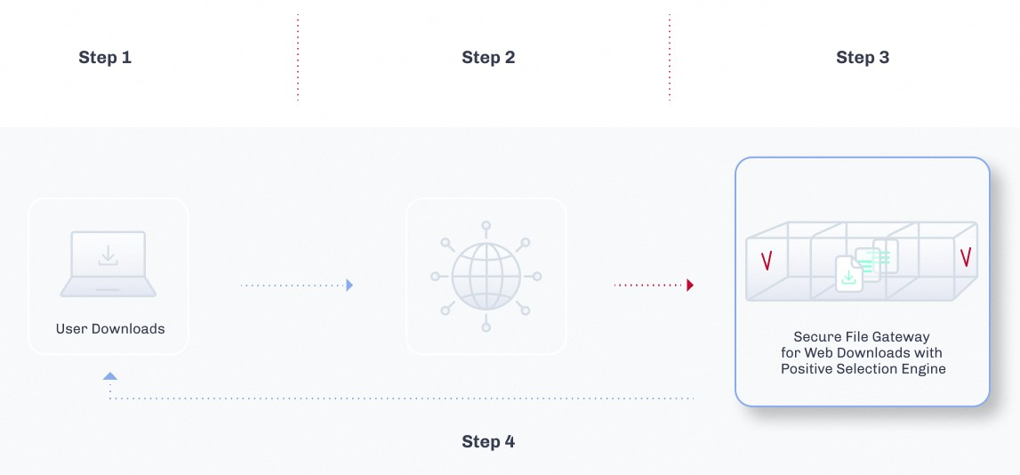

Data is transferred and processed in the following manner:

1. Votiro Cloud for Web Downloads behaves as a user application with respect to Votiro Cloud, which is at the heart of the solution. Votiro Cloud for Web Downloads connects to Votiro Cloud using Votiro Cloud for Web Applications.
2. A file enters the In folder in the external file system. Votiro Cloud for Web Downloads takes a batch of files from the In folder and processing begins.
3. Votiro Cloud for Web Downloads downloads the files together with the name of the positive selection policy to be used to process using Votiro Cloud for Web Applications.
4. When positive selection processing ends, Votiro Cloud uploads the original and processed files to storage for incident management purposes.
5. Votiro Cloud for Web Downloads downloads the processed files to the Out folder in the internal file system.
6. In the event a request is made to release an original file from the blob, Votiro Cloud sends that file to the Out folder, through Votiro Cloud for Web Downloads.

To ensure that the positive selection process does not trigger timeouts, you might need to adjust the timeout values for Votiro Cloud for Web Downloads. For example, the WebApiTimeOutInMS timeout, which defines the total length of time Votiro Cloud for Web Downloads waits for processing to complete.

# Installing Votiro Cloud for Web Downloads

Installation of Votiro Cloud for Web Downloads is performed using an installation wizard.

Following installation, it is recommended you perform various actions to ensure that the installation was successful. See Post-Installation Steps on page 14.

## System Requirements

### Hardware Requirements

**Table 1 Votiro Cloud for Web Downloads Hardware Requirements**

|  |  |  |
| --- | --- | --- |
| **Required Item** | **Minimum Specification** | **Comment** |
| CPU | Dual Core 2.7 GHz | The number of cores is determined by the requested volume of data.  Can be a virtual processor (vCPU) on a virtual machine. |
| RAM | 8 GB |  |
| Operating system drive | 30 GB of free space | Can be a virtual hard disk.  SSD or other fast storage is recommended. |
| Network Card |  | Can be a virtual network card (vNIC) on a virtual machine. |

**Note**

The recommended requirements are based on the projected load. You can calculate the projected load for your organization using the sizing calculator, provided by your Votiro- certified reseller.

### Software Requirements

Make sure to fulfill the following software requirements before you run the Votiro Cloud for Web Downloads setup wizard.

#### Operating System and Services

Microsoft Windows Server 2022, 2019 or 2016, with the latest rollups and updates installed.

#### Software

Microsoft .NET Framework v4.7, v3.5.

**Note**

Google Chrome is installed during the first stage of the installation process of Votiro Cloud for Web Downloads.

### Network Requirements

If Votiro Cloud for Web Downloads requires access to In and Out folders in remote servers, the following firewall rules must be defined.

**Table 2 File Connector Firewall Rules**

|  |  |  |  |  |  |
| --- | --- | --- | --- | --- | --- |
| **Protocol** | **Folder** | **Source Host** | **Source Port** | **Destination Host** | **Destination Port** |
| HTTPS | NA | File Connector server | any | Votiro Cloud | 443/TCP |
| CIFS/UNC | In/Out | File Connector server | any | File Server (hosting In/Out folder) | 139/TCP,  445/TCP |
| FTP(S) | In/Out | File Connector server | any | File Server (hosting In/Out folder) | 21/TCP  (Control Connection) |
| Additional rule for FTP  active mode (server connects client): | | any | 20/TCP  (Transport Connection) |  |
| Additional rule for FTP passive mode (client connects server): | | any | Greater than 1024/TCP  (Transport Connection) |

### Internet Connectivity

An internet connection is required for installing and updating Microsoft components for the operating system.

Votiro Cloud for Web Downloads does not require an internet connection to run the Positive Selection® Engine.

## Running the Installation Wizard

**Note**

You must have administrator permissions for the Microsoft Windows Server on which you are installing Votiro Cloud for Web Downloads.

1. Run the Votiro Cloud for Web Downloads Setup. The setup wizard appears.
2. 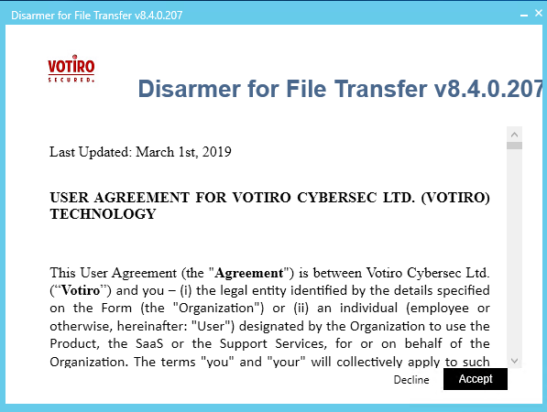Read the license terms and conditions, then click **Accept**.
3. 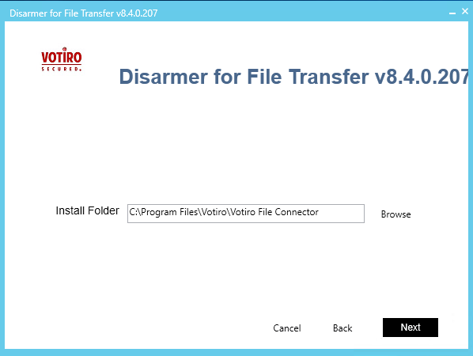Check that the installation path is correct or select a different path.

**Note**

Following the installation, you can configure additional channels. For more information, see Configuring Additional Channels on page 18.

1. Select the protocol by which Votiro Cloud for Web Downloads handles incoming and outgoing files from:
   * Local Path
   * FTP
   * FTPS
   * CIFS/UNC.

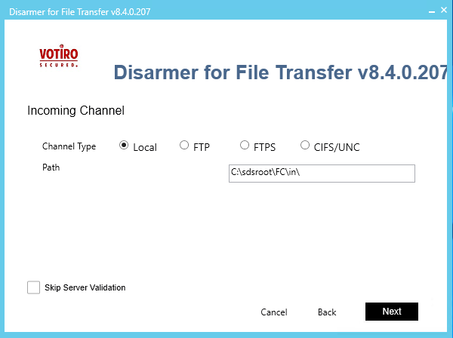

Provide details of the channel, as follows:

* + **For Local Path**: Check that the In folder that the wizard assigns is appropriate to your setup, or specify another folder. Click **Next**. In the screen that follows, check that the Out folder that the wizard assigns is appropriate to your setup, or specify another folder. Click **Next**.
  + **For FTP/FTPS**: Provide username, password, host name and remote path to the In folder. Click **Next**. In the screen that follows, provide details for the Out folder. Click **Next**.
  + **For CIFS/UNC**: Provide username, password, host name, remote path, and domain to the In folder. Click **Next**. In the screen that follows, provide details for the Out folder. Click **Next**.

**Note**

A CIFS/SMB Error 1219 might be evoked in Votiro Cloud for Web Downloads, due to a known Microsoft issue. For more information, see: [https://support.microsoft.com/en-](https://support.microsoft.com/en-us/kb/2807716) [us/kb/2807716](https://support.microsoft.com/en-us/kb/2807716).

1. Provide details of the Votiro Cloud to which Votiro Cloud for Web Downloads must connect:
   * From the Service Protocol list, select *http* or *https*.
   * Specify the Votiro Cloud host name.
   * Leave the value in the *API Version* field unchanged unless instructed otherwise by support personnel.
2. Click **Next**.

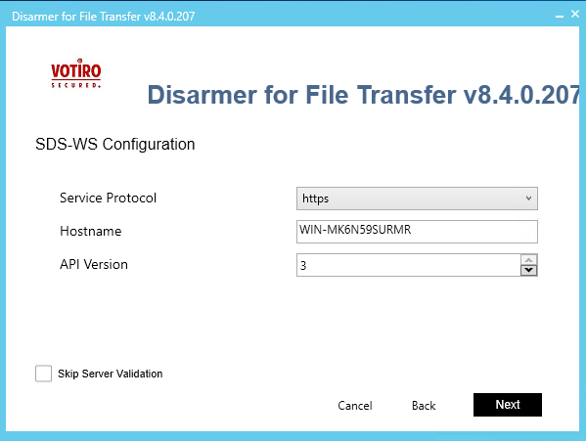

1. Provide details of the Management Dashboard to which Votiro Cloud for Web Downloads must connect.
   * Enter the authentication token specified in the configuration files of the Management Dashboard.
   * Enter the address of the Management Dashboard.

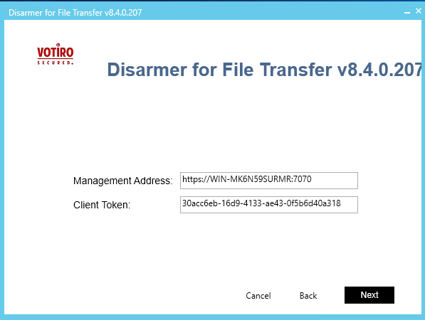

1. Select a certificate authority. Accept the default Votiro setting, or specify your organization's SSL certificate authority, together with the password.

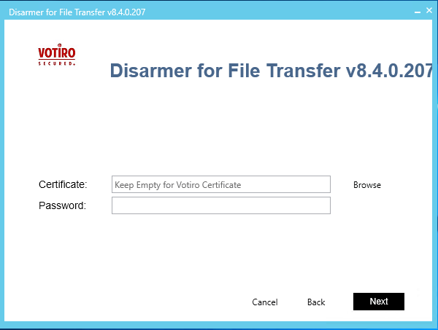

1. Provide the Votiro Cloud for Web Downloads details:
   * Enter a name for the connector. The name appears in filaterable lists in the Management Dashboard.
   * Click **Generate** to generate a connector ID.
2. Click **Next**.

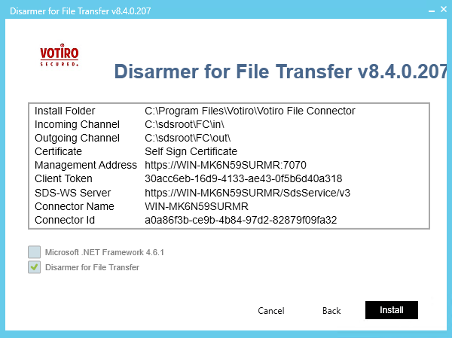The setup wizard displays a summary of the installation details.

1. Click **Install** to confirm and start the installation, or **Back** to make modifications. Installation of Votiro Cloud for Web Downloads begins.

When the installation is completed, the following window is displayed:

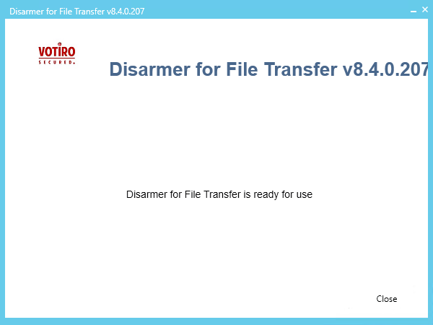

1. Click **Close**.

## Post-Installation Steps

After you have completed the installation process, verify that the installation was successful.

### Verifying that the File Connector Service is Running and Active

* + - 1. Navigate to the Windows Services screen: **Windows** > **Administrative Tools** >

##### Services.

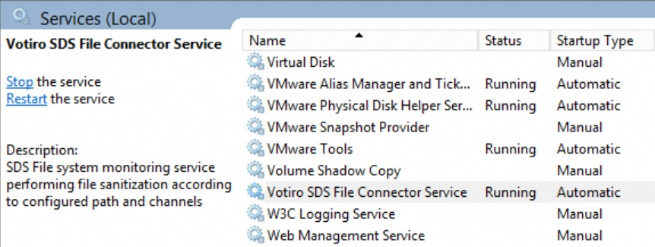Locate the Votiro SDS File Connector service.

* + - 1. Ensure that the following details are displayed:
         * Status is Running.
         * Startup Type is Automatic.

### Verifying that File Processing for Positive Selection is Active

Verify that file processing for positive selection is working properly:

* + - 1. Navigate to the In folder that you specified during installation.
      2. Add a simple text file containing at least 20 ASCII characters.
      3. Navigate to the Out folder and verify that the processed file is present.

### File Changes During Positive Selection Processing

A file that is being processed undergoes the following changes:

* + - 1. When file processing begins, the file name is appended with the extension

_*XXXX*.[machine_name].InProcess, where *XXXX* is an internal, numeric identifier. For example: Filename.pdf_1234.server1.InProcess

* + - 1. When processing is complete, the file name is updated with the extension

_ *XXXX*.[machine_name].Done, where *XXXX* is an internal numeric identifier, or the file is deleted, depending on the value you have specified for the DeleteAfterSanitization parameter.

For example: Filename.pdf_1234.server1.Done

* + - 1. After processing is complete, the file is moved to the Out folder with the original file name or, if the file has been blocked, the suffix _blocked is added to the filename.

For example: Filename.pdf becomes Filename.pdf_blocked.pdf

If a file name already exists in the Out folder, Votiro Cloud for Web Downloads appends a number, starting with 1, to the end of the file name. The numbers increase consecutively for each additional file with the same file name.

Positive Selection policy is specified per channel in the FileConnector.config file. For more information, see Configuring Additional Channels on page 18.

## Uninstalling Votiro Cloud for Web Downloads

To uninstall Votiro Cloud for Web Downloads, use the Programs and Features function on the Control Panel.

1. Right-click **Votiro File Connector** and click **Uninstall**.
2. Click **Yes** in the confirmation dialog to uninstall.

# Configuring Votiro Cloud for Web Downloads

## Configuring File Connector

Configuration changes can be made in the following files, to customize Votiro Cloud for Web Downloads:

|  |  |
| --- | --- |
| **Filename Description** | |
| FileConnector.config | Configures the remote host location, threshold limits, timeouts, and policy parameters. |
| Logs.xml | Defines the severity level of data that is logged, the number of files to back up, the maximum file size, and whether the logged information must be saved as a file or sent to Windows Event Viewer. |

The files are located in the installation folder designated during the installation. The default directory location is: C:\Program Files\Votiro\Votiro File Connector.

The different parameters in the configuration files are described in this chapter. Default configuration values are specified in the configuration files; modify them as needed.

To add channels to Votiro Cloud for Web Downloads, see Configuring Additional Channels on page 18.

## Policy Configuration

Simple policies are a list of filter action-value pairs that are attached to every positive selection process request. Simple policies are provided with true or false values. The default value is true.

For more information about configuring policies, see Votiro Cloud User Guide.

Policy definitions appear in the <Policies> section of FileConnector.config. Each policy is defined in a <PolicyParams> section. The name defined for the Name attribute can be referenced by “PolicyConfigurationName" from a specific channel configuration.

<Policies>

<PolicyParams Name="Foo">

<PredefinedPolicy PolicyName="Default Policy" />

<PolicyRules>

<add Name="CleanOffice" Value="true" />

<add Name="CleanPdf" Value="true"/>

<add Name="CleanImages" Value="true"/>

<add Name="CleanCad" Value="true"/>

<add Name="ExtractEmls" Value="true"/>

<add Name="BlockPasswordProtectedArchives" Value="true"/>

<add Name="BlockPasswordProtectedOffice" Value="true"/>

<add Name="BlockPasswordProtectedPdfs" Value="true"/>

<add Name="BlockAllPasswordProtected" Value="true"/>

<add Name="Blockunsupported" Value="true"/>

<add Name="ScanVirus" Value="true"/>

<add Name="BlockUnknownFiles" Value="true"/>

<add Name="ExtractArchiveFiles" Value="true"/>

<add Name="BlockEquationOleObject" Value="true"/>

<add Name="BlockBinaryFiles" Value="true"/>

<add Name="BlockScriptFiles" Value="true"/>

<add Name="BlockFakeFiles" Value="true"/>

</PolicyRules>

</PolicyParams>

</Policies>

By default, the configuration file contains the following named policy reference:

<PredefinedPolicy PolicyName="Default Policy"/>

A named policy, is a collection of policy rules that override the simply policy. If you specify a name for the named policy in the configuration, simple policy definitions under

<PolicyRules> are ignored.

The header in each positive selection request issued by Votiro Cloud for Web Downloads specifies the policy to apply at time of processing. Use the FileConnector.config file to determine the policy to apply to each channel In folder. Apply the following rules:

* To process files using a policy that is maintained in Votiro Management, specify a policy name for the PolicyConfigurationName parameter in the channel definition. For example:

<Channel Name="a" ... PolicyConfigurationName="HR"

...

/>

Then, for the <PredefinedPolicy> element, specify the policy name as it appears in the Management Dashboard, for example, HR Policy:

<Policies> <PolicyParams Name="HR"> <PredefinedPolicy PolicyName="HR Policy" />

* To process files using a policy that is associated with an Active Directory group, first, ensure that

the PolicyName parameter is left blank:

<PredefinedPolicy PolicyName="" />

then in the channel definition, specify a user that appears in the relevant Active Directopry group. For example:

<Channel Name="a" ... User="Joe Smith"

...

/>

Instead of the user name, you can use the $FirstFolder and $LastFolder identifiers to indicate the usernames under the path defined for the In folder.

## Configuring Additional Channels

For every Votiro Cloud for Web Downloads, you can configure several channels. Define each channel as follows:

<Channel Name="[name]" In="[In_folder]" Out="[Out_folder]"

[PolicyParam1="value1" PolicyParam2="value2"...]/>

Specify [*In_folder]* and [*Out_folder*] using the following syntax:

|  |  |
| --- | --- |
| **Protocol Syntax** | |
| FTP | ftp://[*username*]:[password]@[*IP_address_or_hostname*]/[*folder*]/  **Note**  Make sure you add a "/" at the end of the path. |
| FTPS | ftps://[*username*]:[password]@[*IP_address_or_hostname*]/[*folder*]/  **Note**  Make sure you add a "/" at the end of the path. |
| CIFS/UNC | \\[*IP_address* or *domain_name*]\[*username*]:[password]@[*IP_address* or  *hostname*]\[folder]\  **Note**  Make sure you add a "\" at the end of the path. |

**Note**

Ensure that the path, file name, user name, and password you specify meet with the requirements listed in Illegal Characters on page 20.

The following parameters are available for a channel:

**Table 3 Channel Configuration Parameters**

|  |  |
| --- | --- |
| **Parameter Description** | |
| Name | Unique channel name. This property makes logs more easily readable. It is recommended to choose a name that is descriptive of the channel. The channel name appears in the UI.  Mandatory. |

|  |  |
| --- | --- |
| **Parameter Description** | |
| In | Path of input folder. The folder must be accessible for read, list, write, modify and delete permissions.  Mandatory. |
| Out | Path of output folder. The folder must be accessible for read, list, write, modify and delete permissions.  Mandatory. |
| PolicyConfigurationName | The named policy that the channel will use.  If left undefined, the channel will apply a default policy. |
| User | Active Directory username. |
| MaxFileSizeInBytes | Maximum file size permitted to be processed. Files larger than the specified size remain in the input folder.  The default value is long.maxvalue.  Optional. |
| IgnoreEmptyFile | Specifies if files of 0 bytes must be processed. Disregarded files remain in the input folder.  The default value is true. |
| IgnoreFilesWithoutExtension | Specifies if files without extension must be processed. Disregarded files remain in the input folder.  The default value is false. |
| DeleteAfterSanitization | Specifies if processed files must be deleted from the input folder. If files remain, they are renamed with the extension .Done.  The default value is true. |
| InProcessItemsLimit | The maximum number of files that a channel can mark as InProcess. If no limit is set, all the files inside the input folder will be marked as InProcess for a given channel.  This prevents all other file connectors configured for this folder from processing those files.  The default value is 3000.  **Note**  The maximum value is 999999999. |
| FileNotChangedInSeconds | Number of seconds to wait for a file’s size or last modified property to change before it can be marked as InProcess.  The default value is 2. |

|  |  |
| --- | --- |
| **Parameter Description** | |
| ExcludedExtensions | File extensions to ignore.  In case you are using the File Connector for scanning a browser download folder, it is recommended to add the following temporary extensions to this parameter:  "internet explorer" Value=".partial" "firefox" Value=".part" "chrome" Value=".crdownload""  The default value is " ". |
| ContextIdentifier | Identifier that enables easy identification.  **Note**  An empty string "" is considered a legal value for this parameter.  If you specify "$LastFolder", the subfolder (under the path defined for In) that contained the processed file is the identifier. If the file was in the root folder, however, an empty string "" is returned.  The default value is [MachineID]-[Channel Name]. |

#### Illegal Characters

Avoid using the following characters when configuring a path, file name, user name, or password:

* < (less than)
* > (greater than)
* : (colon), except where the syntax requires it, as in: ftp://XXX.XXX.XXX.XXX
* " (double quote)
* / (forward slash), except where the syntax requires it, as in: ftp://XXX.XXX.XXX.XXX
* \ (backslash), except where the syntax requires it, as in: \\XXX.XXX.XXX.XXX
* | (vertical bar or pipe)
* ? (question mark)
* * (asterisk)

#### Escaping Characters in Username or Password

* The colon and at sign (: and @) can be used in the username field by escaping them first with a backslash (\).
* The colon, at sign, forward slash, and backslash (:, @, /, and \) can be used in the password field by escaping them first with a backslash (\).

#### Example

The following example illustrates the configuration of channels that use all the supported protocols.

<Channels>

<Channel Name ="FC1" In="c:\sdsroot\FC\in\" Out="c:\sdsroot\FC\out\"

PolicyConfigurationName="DefaultPolicy" IgnoreEmptyFile="true"

DeleteAfterSanitization="true" InProcessItemsLimit="3000" FileNotChangedInSeconds="2" ExcludedExtensions="" IgnoreFilesWithoutExtension="False" ContextIdentifier="HR_files"/>

<Channel Name ="FC_FTP" In="ftp://user1:password1@10.105.1.25/IN" Out="ftp://user1:password1@10.105.1.25/OUT" PolicyConfigurationName="DefaultPolicy" IgnoreEmptyFile="true" DeleteAfterSanitization="true" InProcessItemsLimit="3000" FileNotChangedInSeconds="2" ExcludedExtensions="" IgnoreFilesWithoutExtension="False"/>

<Channel Name ="FC_FTPS" In="ftps://user2:password2@10.105.1.28/IN" Out="ftps://user2:password2@10.105.1.28/OUT" PolicyConfigurationName="DefaultPolicy" IgnoreEmptyFile="true" DeleteAfterSanitization="true" InProcessItemsLimit="3000" FileNotChangedInSeconds="2"

ExcludedExtensions="" IgnoreFilesWithoutExtension="False"/>

<Channel Name ="FC_UNC In="\\10.105.1.22\User3:Password3@10.105.1.22\In\" Out="\\10.105.1.22\User3:Password3@10.105.1.22\Out\" PolicyConfigurationName="DefaultPolicy" IgnoreEmptyFile="true" DeleteAfterSanitization="true" InProcessItemsLimit="3000" FileNotChangedInSeconds="2"

ExcludedExtensions="" IgnoreFilesWithoutExtension="False"/>

</Channels>

## General Configuration Parameters

**Table 4 File Connector General Configuration Parameters**

|  |  |  |
| --- | --- | --- |
| **Parameter** | **Description** | **Value** |
| MachineID | A unique ID assigned to the machine. It is used internally to associate files from channel inputs with a specific File Connector.  **Notes**   * If you have configured your system so that several File Connectors use the same channels, ensure that the MachineId for each File Connector is unique. * The MachineID name may not contain the _ (underscore) character. | Generated during installation, as a unique identifier. |
| ConnectorName | Defines a unique connector name. The name appears in filterable lists in the Management Dashboard. | Set during installation and must not be changed. |
| ConnectorID | Defines a connector ID. | Set during installation and must not be changed. |

|  |  |  |
| --- | --- | --- |
| **Parameter** | **Description** | **Value** |
| ScanIntervalInMS | Defines how often (in milliseconds) a channel’s input will be scanned for new files. | The default value is 3000. |
| MaxWebApiThreads | The maximum number of files that can be processed by the Votiro API. This is a cross-channel setting.  The default value is 30. | NA |

## Votiro Cloud for Web Applications Configuration Parameters

You can configure different parameters related to Votiro Cloud for Web Applications.

Thresholds and timeouts are important because they affect the positive selection processing of each file that passes through Votiro Cloud for Web Downloads to the Votiro Cloud. For each file, several requests pass between Votiro Cloud for Web Downloads and Votiro Cloud—from the initial handshake, through various status check requests, to completion of positive selection processing. If thresholds and timeouts are not specified appropriately, files might be returned in an error state.

You modify thresholds and timeouts in the FileConnector.config file. The following parameters can be configured:

**Table 5 Votiro Cloud for Web Applications Configuration Parameters**

|  |  |  |
| --- | --- | --- |
| **Parameter** | **Description** | **Value** |
| **WebApiSettings** | | |
| WebApiRemoteHost | Address of Votiro Cloud. | The default value is: https://<*domain_ host*>/SDSService/v3. |
| WebApiTimeOutInMS | The total length of time Votiro Cloud for Web Downloads waits for positive selection processing to be complete, in milliseconds. When the timeout is reached, the file name becomes:  <*file_name*>_error. | Range: 5000 to 180000000  The default value is 90000. |
| WebRequestTimeoutInMS | The length of time Votiro Cloud for Web Downloads waits per API request from Votiro Cloud, in milliseconds. When the timeout is reached, the file name becomes: <*file_name*>_error. | Range: 5000 to 180000000  The default value is 60000. |

|  |  |  |
| --- | --- | --- |
| **Parameter** | **Description** | **Value** |
| WebApiStatusCheckIntervalInMS | The length of time Votiro Cloud for Web Downloads waits before a periodic status is sent to Votiro Cloud, in milliseconds. | Range: 1 to 5000  The default value is 100. |
| WebApiNumberOfRetries | Number of retries to perform in case one of the following HTTP error codes is returned by Votiro Cloud:  404: Not Found  500: Internal Server Error | Range: 0 (minimum) Default value is 5. |
| CloudAPIKey | Required only if you are using the Votiro Cloud API, or if you defined a token in the webapi.xml file. | Token |
| **WebServiceSettings** | | |
| Protocol | Protocol. | HTTP or HTTPS  The default value is HTTPS. |
| Port | Port. | The default value is 6060. |

## Logs Configuration Parameters

The Votiro Cloud for Web Downloads installation has its own log file that allows Votiro to trace the activity in that component. Logs may include:

* + - The files taken from the In directory.
    - The files forwarded to Votiro Cloud and processed.
    - The files that were successfully sent to the Out directory and which failed.

The log file is located in the installation folder. The default location is: C:\Program Files\Votiro\Votiro File Connector\Logs.

The following log parameters can be configured:

**Table 6 Log Configuration File Parameters**

|  |  |  |
| --- | --- | --- |
| **Parameter** | **Description** | **Value** |
| **AppenderConfig** | |  |
| Type | Specifies the log type. | File or EventViewer |

|  |  |  |
| --- | --- | --- |
| **Parameter** | **Description** | **Value** |
| LogLevel | Specifies the severity level of data that is logged.  You can have more than one LogLevel attribute in the file. For example, you might choose to log Warning, Error, and Fatal events. | Verbose, Debug (default), Info, Notice, Warning, Error, Fatal. |
| Parameters relevant to File logs only: | | |
| NumberOfBackups | Specifies the number of files that can be backed up before file rotation occurs. When files are rotated, the first file that was created (the oldest file) is overwritten first. | A positive integer. The default value is 10. |
| MaxFileSize | Specifies how large the log file can be before a new file is created. | A file size greater than zero, including the measurement being used, for example 40MB. The default value is 5MB. |
| FileFolder | Specifies the name and location of the folder where the log files are stored. If the value is empty, the folder is defined by the system as  %HomeDirectory%\Logs.  If you specify a value, it must be the full path of the folder. | The name of the folder, in the format [drive]:\ [path]\[folder], for example, C:\Votiro\Logs\. The default value is Logs. |
| FileName | Specifies the name of the file.  Use ASCII characters when specifying a file name. | The name file, in the format [logname].log, for example, sds.log. The default is VotiroFileConnector_%ComputerName_%.log |
| Locking |  | The default value is ExclusiveLock. |
| ImmediateFlush |  | The default value is false. |
| Parameter relevant to Event Viewer logs only: | | |
| ApplicationName | Specifies the name of the application that appears under Applications and Services in the Event Viewer. | The name of the application, for example SDS. You must use ASCII characters when specifying the application name. |